**emptyDir volume:**

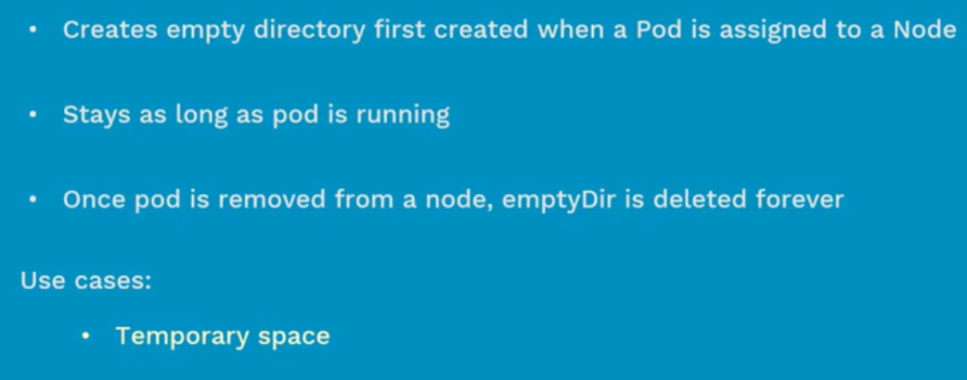

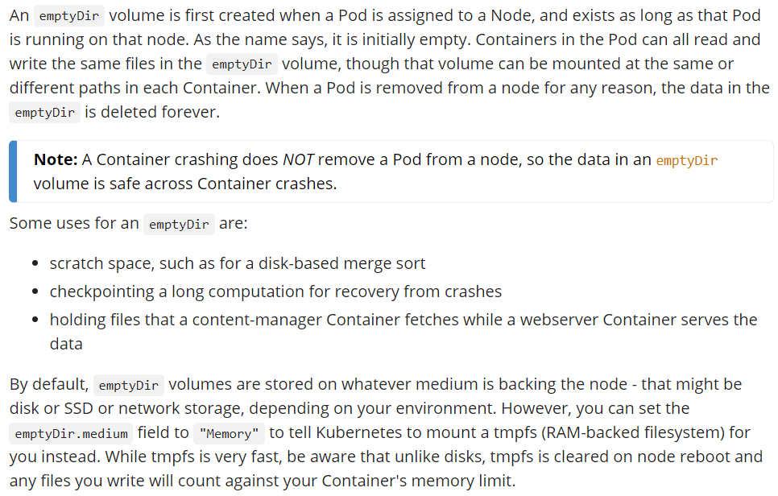

* Volume data will be deleted even if we restart with delete command if it is managed by RC or RS
* By default, this gets mounted with the same size of”/” volume which means same size of the node where pod is scheduled

**Manifest file:**

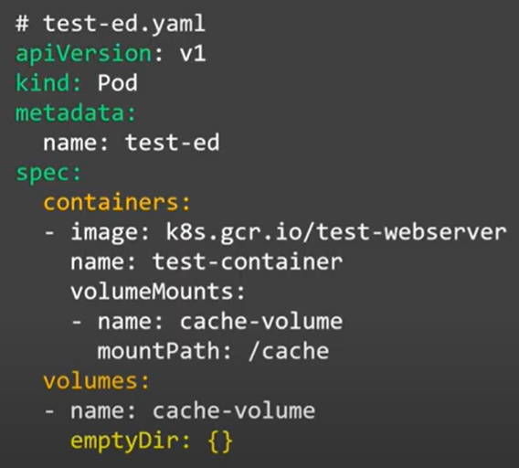

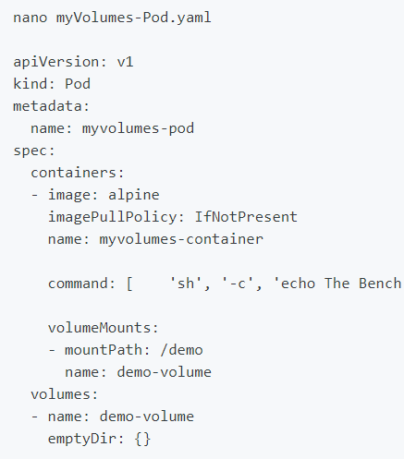

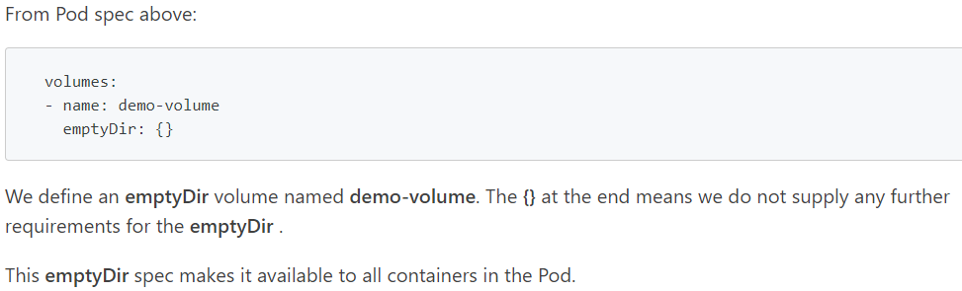

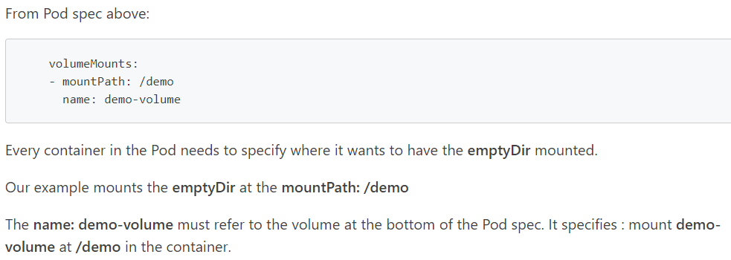

**Sharing volumes with multiple containers in POD:**

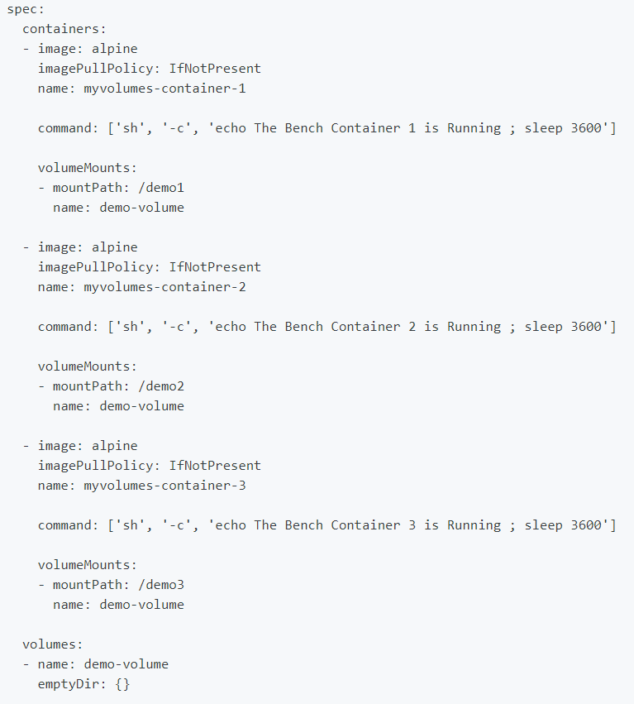

* So, here all the data inside that directory will be shared equally by the containers of the POD.

**emptyDIr created in RAM:**

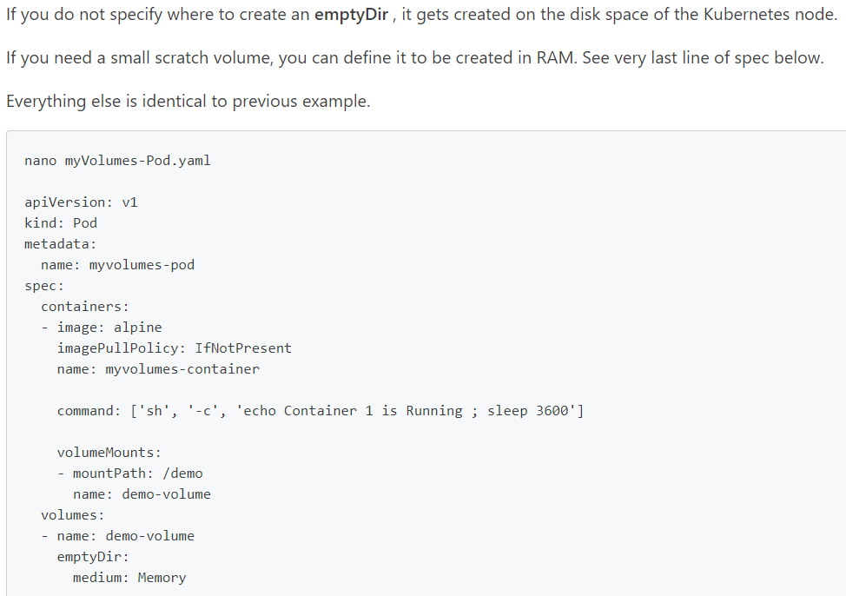

* Now, when we create the POD, we can see it mounted as **“tmpfs”** file system because we used medium memory. If we don’t mention that. It will be mounted as **“/dev/sda1”** file system

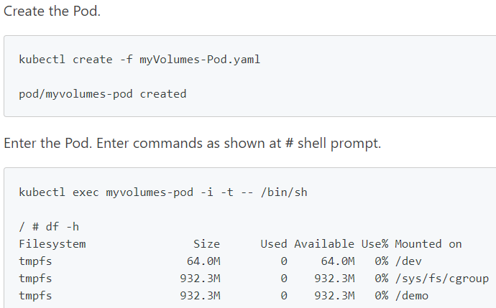

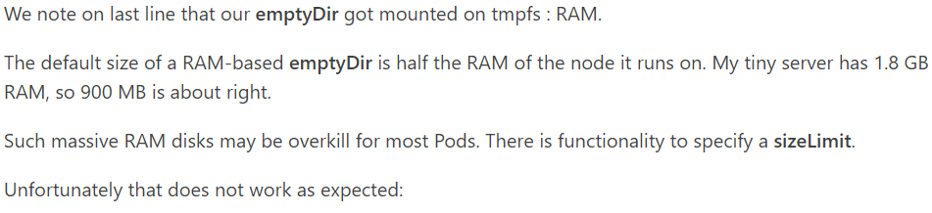

**Create & display:**

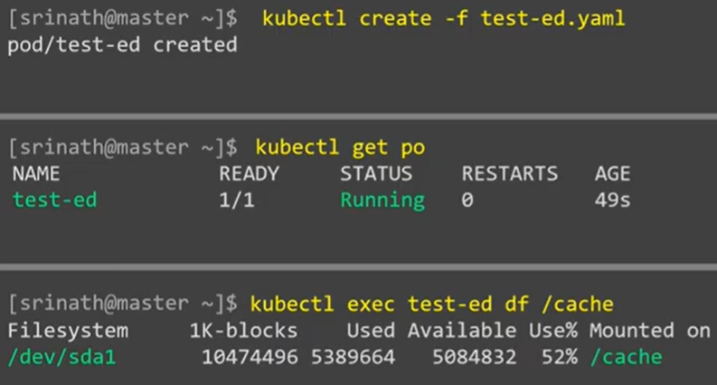

* As above, we can see **“/cache”** was created in pod and this can be used to store anything in POD.

**Describe:**

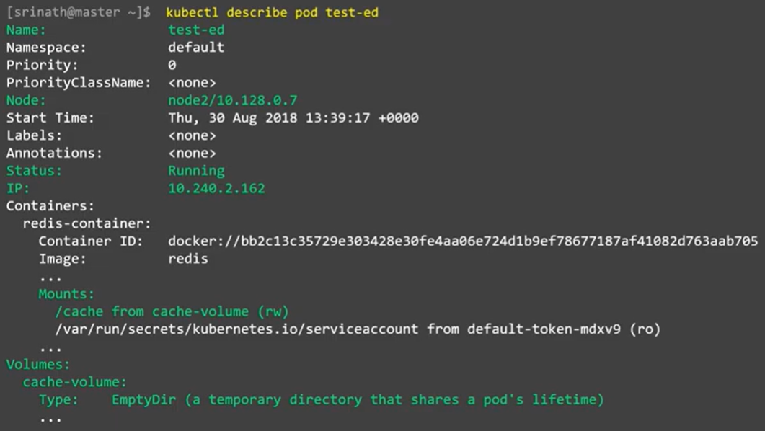

**Delete:**

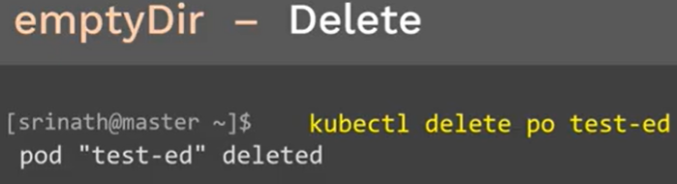

* If we delete the POD, emptyDir will also be deleted.